
Mathematics Essential

Name: ______________________

Task 2.6 – Unit 2

Assessment type: Response - Skills

Conditions:

Time for the task: 30 minutes

In class, calculator permitted
Marks: marks ______/ 20

Task weighting:

2% of the school mark for this unit

_____________________________________________________________________________
Question 1 ( 6 Marks):
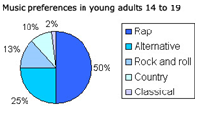
a)
If there were a total of 205 young adults surveyed, approximately how many preferred Rock and Roll?

________________

Rock and Roll

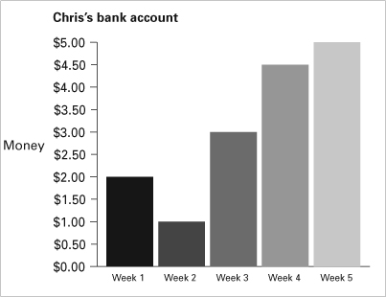
b)
The amount in the bank for Week 4 is how much greater that the amount for Week 2.

______________

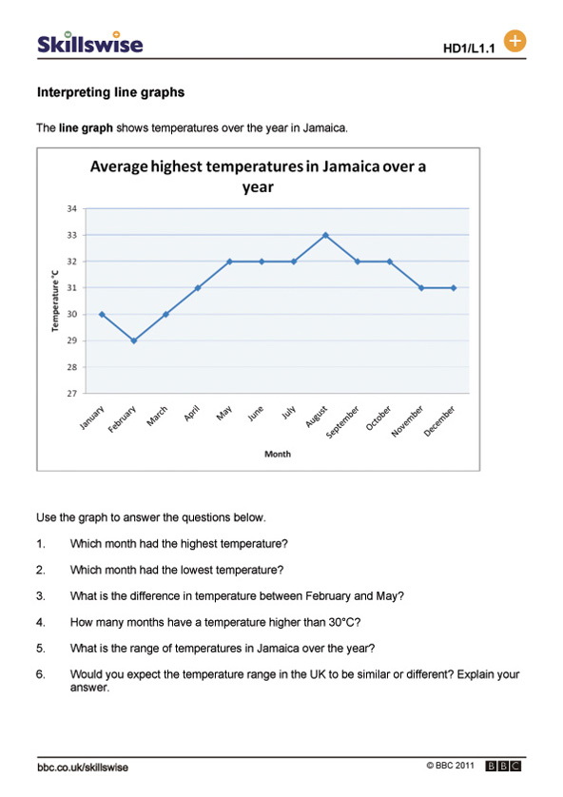
c)
John says that the temperature in Jamaica is always close to xº. Janine agrees with him
and says this is called the Median. Which of these values do you think ‘x’ could be?

_______________

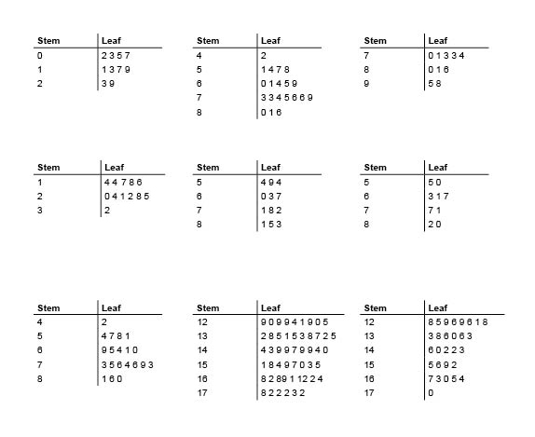
d)
Complete:-
The highest score is the stem and leaf plot is ____

The lowest score in the stem and leaf plot is ____

The RANGE he range of this data is ___________

Question 2 (2 Marks)
- A 75g small serve of French Fries contains 230 calories. If 1 calorie = 4.2 kilojoules, how many kilojoules is there in the 75g serve of French Fries.

- Paul takes his own pulse and finds that it is 26 beats in 15 seconds. How many beats per minute is this?

Question 3: (3 marks: 1, 1, 1)
Complete the table by filling in the missing values:

SCALE | DISTANCE ON THE MAP | REAL LIFE DISTANCE
1:100 | 4cm
1:50 | 18cm
1:1000 |  | 5000m

Question 4: (3 marks)
The profit from a family business was shared by three brothers, Paul, Greg and John, in the ratio of 3:2:1 respectively. If the total profit was $48 000, what was each brothers share?

Question 5: (2 Marks)
Write the differences between the two times

- 4:45 p.m. and 6:40 p.m.

- 9:55 a.m. and 1:20 p.m.

Question 6: (2 marks: ½, ½, ½, ½)
Write typical units used for each of the following rates:

- price of sausages

- petrol cost

- driving speed

- water usage in the shower

Question 6: (2 marks)
Tamara is paid at a fixed rate per hour. If she earns $136 for 5 hours work, how much will she earn for working 8 hours?

